Web based automated Help Desk: 4+1 Views
By Jason Raffi and John Sung
List of Diagrams
• Figure 1 : Highlevel Usecase Diagram 4
• Figure 2 : Employee’s High Level State Diagram 5
• Figure 4 : Employee’s Email Sequence Diagram 6
• Figure 5 : Employee’s Worst Case Email Sequence Diagram 7
• Figure 6 : Mentor State Diagram 7
• Figure 7 : Employee Web Search State Diagram 8
• Figure 8 : Employee’s Worst Case Phone Diagram 8
• Figure 3 : Emergency Phone Sequence Diagram 9
• Figure 9 : Database Class Diagram 10
• Figure 10 : Webpage Class Diagram 11
• Figure 11 : Chat Server Class Diagram 11
• Figure 12 : Chat Client Class Diagram 12
• Figure 13 : DatabaseEngine Class Diagram 12
• Figure 14 : Chat Server Activity Diagram 13
• Figure 15 : Chat Client Process View 14
• Figure 16 : Database Engine Activity Diagram 15
• Figure 17 : Overall Schedule 16
• Figure 18 : Mentor Phase Class Diagram 16
• Figure 19 : Reference Card Class Diagram 17
• Figure 20 : FAQ Database Class Diagram 17
• Figure 21 : Email Phase Class Diagram 18
• Figure 22 : Phone Phase Class Diagram 18
• Figure 23 : Chat Class Diagram 19
• Figure 24 : Chat SubSystem Component Diagram 19
• Figure 25 : System Deployment Diagram 20

Introduction

Background
The leading technology consultant company, COM 3205 Inc., was asked to propose a new system that would convert the existing Help Desk System to a more efficient, web based automated Help Desk. The senior consultants, Jason Raffi and John Sung, have met with the company in question and drafted a document to propose several possible solutions to their requirements of the new web based Help Desk.
This document contains the 4+1 view of software that goes along with the document that was submitted earlier. These views should give a more detailed view of how the whole project should look like. The views will be given with multiple UML diagrams.

4+1 View Model of Software Architecture
This model of software architecture was developed my Rational Software Corp. It attempts to communicate the different issues that any software engineer has to consider when developing a software system.
Logical View - the object model of the design
Process View - the concurrency and synchronization aspects of the design
Physical View - the mapping of the software onto the hardware and reflects it's distributed aspects.
Development View - that static organization of the software in it's development environment.
Scenarios - the use cases that illustrate how the actors will use the system.

Scenarios
- Figure 1 : Highlevel Usecase Diagram
- Figure 2 : Employee’s High Level State Diagram

- Figure 3 : Employee’s Email Sequence Diagram
- Figure 4 : Employee’s Worst Case Email Sequence Diagram
- Figure 5 : Mentor State Diagram
- Figure 6 : Employee Web Search State Diagram
- Figure 7 : Employee’s Worst Case Phone Diagram
- Figure 8 : Emergency Phone Sequence Diagram
Logical View

- Figure 9 : Database Class Diagram
- Figure 10 : Webpage Class Diagram
- Figure 11 : Chat Server Class Diagram
- Figure 12 : Chat Client Class Diagram
- Figure 13 : DatabaseEngine Class Diagram
Process View

Overall System Architecture
- Figure 14 : Chat Server Activity Diagram
- Figure 15 : Chat Client Process View

- Figure 16 : Database Engine Activity Diagram
Development View

- Figure 17 : Overall Schedule
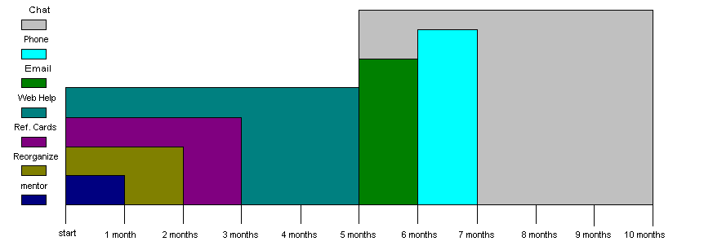
- Figure 18 : Mentor Phase Class Diagram

- Figure 19 : Reference Card Class Diagram
- Figure 20 : FAQ Database Class Diagram

- Figure 21 : Email Phase Class Diagram
- Figure 22 : Phone Phase Class Diagram
- Figure 23 : Chat Class Diagram
- Figure 24 : Chat SubSystem Component Diagram
Physical View
- Figure 25 : System Deployment Diagram

