COM 1101 Algorithms and Data Structures 1
Midterm: February 7, 2002
Professors Proulx, Raab, & Rasala

Name: Student ID:

1: 40 | 2: 20 | 3: 40 | Total

Problem 1: The MapPoint Class (40 Points)
In this problem, you will define a class MapPoint that represents a location of some point on Earth. The point on earth will be represented by two member data variables latitude and longitude of type double. The values of latitude may range from -90 to +90. The values of longitude may range from -180 to +180. The class itself, its constructors, and its member functions should all be public. The member data variables should be protected.
To make the problem easier to grade, you will be asked to supply the definitions in stages rather than all at once.
(A:2) Give the class header for class MapPoint that would normally enclose the rest of the class definition.

public class MapPoint { ... }

(B:2) Give the definitions of the two protected member variables latitude and longitude of type double and initialize these variables to zero.

protected double latitude = 0;

protected double longitude = 0;

(C:8) Define the following four set functions.
The setLatitude function will take one double parameter newLatitude. If the value given is greater than 90, the latitude must be set to 90; if the value given is less than -90, the latitude must be set to -90; otherwise the latitude must be set to the given value:
public void setLatitude(double newLatitude)
{
if (newLatitude > 90)
latitude = 90;
else
if (newLatitude < -90)
latitude = -90;
else
latitude = newLatitude;
}

The setLongitude function will take one double parameter newLongitude. The resulting longitude must be within the range -180 to +180, so that the geometry of traveling around the globe works correctly. In order to assure the result will be in the proper range, you should use the following helper function (assume it works!):

protected double adjustLongitude(double value){
double temp = value % 360 + 360;
return ((temp + 180) % 360 - 180);
}

The above helper function will return the appropriate longitude value in the range -180 to +180, for any double value, whether positive, zero, or negative. Use this function to define:
public void setLongitude(double newLongitude)
{
longitude = adjustLongitude(newLongitude);
}

The first setMapPoint function will take two double parameters and must set both the latitude and the longitude accordingly (using the previous two set functions).
public void setMapPoint(double newLatitude, double newLongitude)
{
setLatitude(newLatitude);
setLongitude(newLongitude);
}

The second setMapPoint function will take a MapPoint object mp as its parameter. This function must set both latitude and longitude to the corresponding values in the given MapPoint object mp:
public void setMapPoint(MapPoint mp)
{
if (mp == null)
return;

latitude = mp.latitude;
longitude = mp.longitude;
}

(D:6) Define the following three constructors. The first constructor must accept the default values of 0 for both latitude and longitude. The remaining constructors should call the corresponding setMapPoint functions.

public MapPoint()
{
// nothing to do
}

public MapPoint (double newLatitude, double newLongitude)
{
setMapPoint(newLatitude, newLongitude);
}

public MapPoint (MapPoint mp)
{
setMapPoint(mp);
}

(E:4) Define two get functions, one for each member data variable. You must write the entire function definitions, including the function headers.

public double getLatitude() {
return latitude;
}

public double getLongitude() {
return longitude;
}

(F:2) Define a boolean function inWesternHemisphere that returns true if the longitude has value <= 0 and false otherwise. You must write the entire function definition.

public boolean inWesternHemisphere() {
return longitude <= 0;
}

(G:2) Define a boolean function inNorthernHemisphere that returns true if the latitude has value >= 0 and false otherwise. You must write the entire function definition.

public boolean inNorthernHemisphere() {
return latitude >= 0;
}

(H:4) Define two functions changeLatitude and changeLongitude that change the corresponding data member values by adding the given value. The resulting latitude and longitude must satisfy the original constraints.
public void changeLatitude(double value)
{
setLatitude(latitude + value);
}

public void changeLongitude(double value)
{
setLongitude(longitude + value);
}

(I:2) Define a function named changeMapPoint that will change both member data variables by the adding the given values, again preserving the original constraints.
public void changeMapPoint(double latitudeValue, double longitudeValue)

{
changeLatitude(latitudeValue);
changeLongitude(longitudeValue);
}

(J:8) Define three MapPoint objects, and use the member functions in the MapPoint class, as follows:
Define a new object named greenwich, initialized to latitude 51.5 and longitude 0

MapPoint greenwich = new MapPoint(51.5, 0);

Define a new object named anchorage, initialized to latitude 61 and longitude -150

MapPoint anchorage = new MapPoint(61, -150);

Define a new object named newPlace that represents exactly the same map location as anchorage. Change its latitude by -40 and change its longitude by -8.

MapPoint newPlace = new MapPoint(anchorage);

newPlace.changeMapPoint(-40, -8);

Write code that will print whether or not greenwich is in the Northern Hemisphere, and whether or not anchorage is in the Western Hemisphere.

String insert = greenwich.inNorthernHemisphere() ? "" : "not ";

console.out.println("Greenwich is " + insert + "in the Northern Hemisphere");

insert = anchorage.inWesternHemisphere() ? "" : "not ";

console.out.println("Anchorage is " + insert + "in the Western Hemisphere");

Write code that will print the latitude and longitude (with appropriate text labels) of the object newPlace.

console.out.println("New place latitude: ", newPlace.getLatitude());

console.out.println("New place longitude: ", newPlace.getLongitude());

Problem 2: Dot Patterns (20 Points)
In the Dot Patterns laboratory, you wrote loop patterns to draw dots in various arrangements. You did your work by adapting the following template wrapper:

protected final static DotPattern patternName =
new DotPattern() {
protected void draw() {
// pattern loop code using calls
// of the form dot.draw(row, col)
};
};

(A:10) Write the loop code that will produce the following pattern. You do not need to copy the template wrapper.
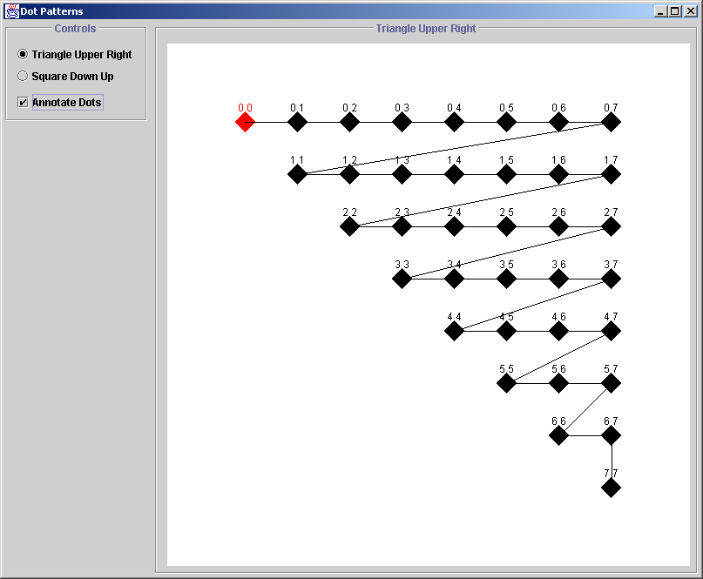

for (int row = 0; row <= 7; row++)
for (int col = row; col <= 7; col++)
dot.draw(row, col);

(B:10) Write the loop code that will produce the following pattern. You do not need to copy the template wrapper.

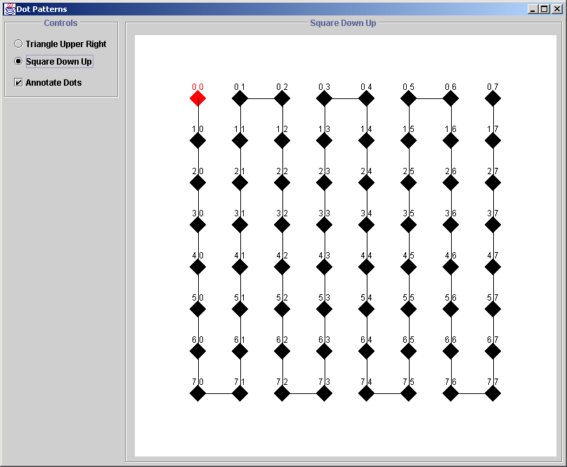

boolean down = true;

for (int col = 0; col <= 7; col++) {
if (down)
for(int row = 0; row <= 7; row++)
dot.draw(row, col);
else
for(int row = 7; row >= 0; row--)
dot.draw(row, col);

down = ! down;
}

Problem 3: Java Arrays: Type Double (40 Points)
In this problem, you will work with pure Java arrays whose data is of type double. You should perform the steps in order since each step may affect a subsequent step.
(A:2) Define an array reference variable named data of type double and initialize this array to null.

double[] data = null;

(B:2) Create a new array of type double with a length of 15, and assign this new array to the array reference variable named data.

data = new double[15];

(C:2) What index values are now valid in the array named data?

0, 1, 2, 3, 4, 5, 6, 7, 8, 9, 10, 11, 12, 13, 14

(D:2) What value is now stored at each index of the array named data?

0

(E:4) Write code to assign to each data[i] the value of the formula 4i² - 2i + 5.

for (int i = 0; i < data.length; i++)
data[i] = 4 * i * i - 2 * i + 5;

(F:4) Create a new array of type double initialized to contain the specific elements 4.134, 1.364, 7.138, and 1.482. Assign this new array to the reference variable data.

data = new double[] { 4.134, 1.364, 7.138, 1.482 }

(G:2) What is now the length of the array named data?

4

(H:2) Is it possible now to access the array with 15 elements created in part (B)? Please explain.
No. By assigning a new array to the data variable, we have lost track of the previous 15 element array that was assigned to data.

In the remaining parts of this exercise, you should assume that the parameter data refers to arbitrary array of double, not either of the specific arrays used in the above examples. In each case, be sure to check if data is null and react as specified.
(I:6) Write a function named sum that computes and returns the sum of the array values in data. If the parameter data is null, this function should return 0.

public static double sum(double[] data) {
double s = 0;

if (data == null)
return s;

int length = data.length;

for (int i = 0; i < length; i++)
s += data[i];

return s;
}

(J:6) Write a function named rotateLeft that will rotate left the elements in data, that is, data[1] will be copied to data[0], data[2] will be copied to data[1], and so on, with the first element in the array, data[0], copied to last element of the array. If the parameter data is null, this function should do nothing.

public static void rotateLeft(double[] data) {
if ((data == null) || (data.length <= 1))
return;

int last = data.length - 1;
double temp = data[0];

for (int i = 1; i <= last; i++)
data[i-1] = data[i];

data[last] = temp;
}

(K:8) Write a function named findLarger that will search for and return the index of the first occurrence of an element in the array that has value larger than a given key. If no element is found that is larger or if the array is null, the function must return -1.
The following example explains this process:
0 | 1 | 2 | 3 | 4
3.45 | 2.34 | 6.21 | 5.29 | 12.72

value of key parameter: index returned:
4.0 2
3.0 0
8.0 4
13.0 -1

The header for the findLarger function is given below:

public int findLarger(double[] data, double key)

{
if ((data == null) || (data.length <= 0))
return -1;

int length = data.length;

for (int i = 0; i < length; i++)
if (data[i] > key)
return i;

return -1;
}

Note that, if you interpret larger as >= rather than >, that answer is OK.

