COM 1101 Algorithms and Data Structures 1
Midterm: November 6, 2001
Professors Raab & Rasala

Name: Student ID:

1: 27 | 2: 20 | 3: 38 | 4: 15 | Total

Problem 1: The Pair Class (25 Points)
In this problem, you will define a class Pair to encapsulate two member data variables x and y of type double. The class itself, its constructors, and its member functions should all be public. The member data variables should be protected.
To make the problem easier to grade, you will be asked to supply the definitions in stages rather than all at once.
(A:2) Give the class header for class Pair that would normally enclose the rest of the class definition.

public class Pair { ... }

(B:2) Give the definitions of the two protected member variables x and y of type double and initialize these variables to zero.

protected double x = 0;
protected double y = 0;

(C:6) Define the following three set functions which should simply store the parameters in the corresponding member data variables.

public void setPair(double x, double y) {
setX(x);
setY(y);
}

public void setX(double x) {
this.x = x;
}

public void setY(double y) {
this.y = y;
}

(D:4) Define the following two constructors:

public Pair() { }

public Pair(double x, double y) {
setPair(x, y);
}

The second constructor should call the corresponding set function.
(E:4) Define two get functions, one for each member data variable. You supply the headers.

public double getX() {
return x;
}

public double getY() {
return y;
}

(F:4) Define a boolean function isZero that returns true if both member data variables x and y are zero and false otherwise. You supply the header.

public boolean isZero() {
return (x == 0) && (y == 0);
}

(G:5) Define a function addPair that will add the values in the parameter p to the member data variables, that is, p.x should be added to x and p.y should be added to y. This function should first test if p is null and, if so, it should do nothing and return immediately.

public void addPair(Pair p) {
if (p == null)
return;

x += p.x;
y += p.y;
}

Problem 2: Dot Patterns (20 Points)
In the Dot Patterns laboratory, you wrote loop patterns to draw dots in various arrangements. You did your work by adapting the following template wrapper:

protected final static DotPattern patternName =
new DotPattern() {
protected void draw() {
// pattern loop code using calls
// of the form dot.draw(row, col)
};
};

(A:10) Write the loop code that will produce the following pattern. You do not need to copy the template wrapper.

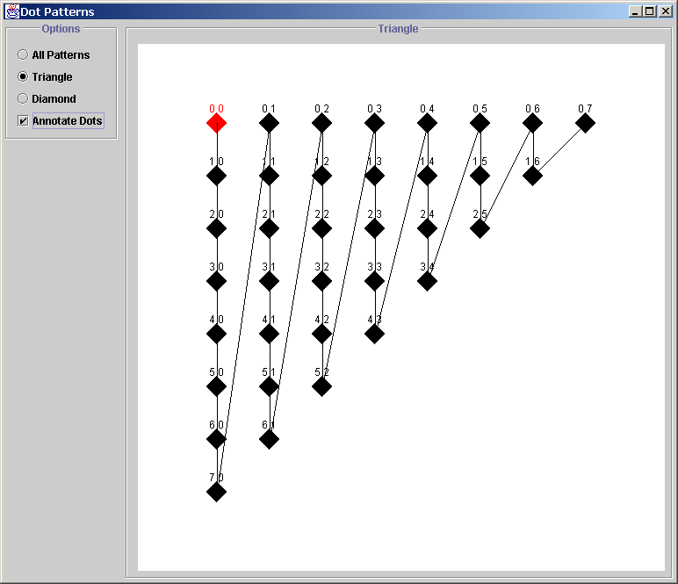

for (int col = 0; col <= 7; col++)
for (int row = 0; row <= 7 - col; row++)
dot.draw(row, col);

(B:10) Write the loop code that will produce the following pattern. You do not need to copy the template wrapper.

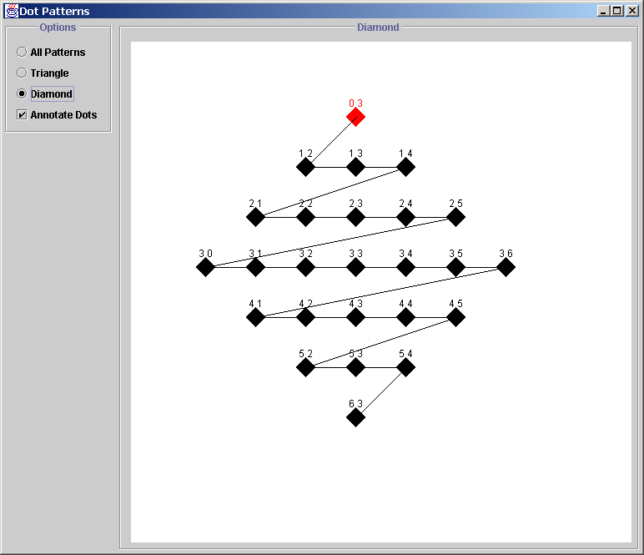

for (int row = 0; row <= 3; row++)
for (int col = 3 - row; col <= 3 + row; col++)
dot.draw(row, col);

for (int row = 4; row <= 6; row++)
for (int col = row - 3; col <= 9 - row; col++)
dot.draw(row, col);

Problem 3: Java Arrays: Type Double (38 Points)
In this problem, you will work with pure Java arrays whose data is of type double. You should perform the steps in order since each step may affect a subsequent step.
(A:2) Define an array variable data of type double and initialize this array to null.

double[] data = null;

(B:2) Create a new array of double with 10 elements and assign this new array to the array variable data.

data = new double[10];

(C:2) What index values i will be valid in data[i]?

0 <= i <= 9

(D:2) What value will be stored in each data[i] initially?

0

(E:4) Write the code to assign to each data[i] the value of the formula i² +3i - 4.

for (int i = 0; i < data.length; i++)
data[i] = i*i + 3 * i - 4;

(F:4) Create a new array of double initialized with the specific elements 1.414, 2.718, and 3.142 and assign this new array to the array variable data.

data = new double[] { 1.414, 2.718, 3.142 };

(G:2) What is now the length of the array data?

3

(H:2) Is it possible now to access the array with 10 elements created in part (B)? Please explain.

No. By assigning a new array to the data variable, we have lost track of the previous 10 element array that was assigned to data.

In the remaining parts of this exercise, you should assume that the parameter data represents an arbitrary array of double not either of the specific arrays used in the above examples. In each case, be sure to check if data is null and react accordingly.
(I:6) Write a function that will compute and return the sum of the array values in data.

public static double sum(double[] data) {
if (data == null)
return 0;

double s = 0;

for (int i = 0; i < data.length; i++)
s += data[i];

return s;
}

In this case, if the parameter data is null, the sum function should return 0.

(J:6) Write a function that will rotate right the elements in data, that is, data[0] will be copied to data[1], data[1] will be copied to data[2], and so on, with the last element in the array copied to data[0].

public static void rotateRight(double[] data) {
if (data == null)
return;

int limit = data.length - 1;
double temp = data[limit];

for (int i = limit; i > 0; i--)
data[i] = data[i-1];

data[0] = temp;
}

(K:6) Write a function that will reverse the elements in data, that is, data[0] will be swapped with the last array element, data[1] will be swapped with the next to last element, and so on.

public static void reverse(double[] data) {
if (data == null)
return;

int i = 0;
int j = data.length - 1;
double temp;

while (i < j) {
temp = data[i];
data[i] = data[j];
data[j] = temp;
i++;
j--;
}
}

Problem 4: Miscellaneous (15 Points)
(A:5) Explain what is wrong with the following line of code that attempts to initialize an int x with the value 50:

int x = new int(50);

Explanation:
This is wrong since, in Java, a primitive type such as int can never be allocated dynamically with new.

Write the code to correct this problem.

int x = 50;

In the next two parts, you will use Point2D.Double. On the next page, you will find a summary with the constructors and selected member functions of this class.
(B:5) Explain what is wrong with the following lines of code that attempt to initialize a Point2D.Double object P with the values 2.3, 3.8.

Point2D.Double P;
P.setLocation(2.3, 3.8);

Explanation:
This is wrong since the object P is never allocated with new and hence is null. You will get a null pointer exception when the line with setLocation is executed.

Write the code to correct this problem.

Point2D.Double P = new Point2D.Double();
P.setLocation(2.3, 3.8);
or
Point2D.Double P = new Point2D.Double(2.3, 3.8);

(C:5) Let P and Q be objects of type Point2D.Double and assume that P has been properly initialized to the values 1, 2 and that Q has been properly initialized to the values 3, 4. Consider the following lines of code.

P = Q;
Q.setLocation(5, 6);
P.setLocation(7, 8);

In the table below, fill in the values of the get functions:

P.getX() | P.getY() | Q.getX() | Q.getY()
7 | 8 | 7 | 8

The issue is that the first line makes P and Q reference the same object so that the changes in lines 2 and 3 apply to the same object.
Summary of Point2D.Double

Constructors:

Point2D.Double()

Point2D.Double(double x, double y)

Selected Member Functions:

setLocation(double x, double y)

setLocation(Point2D p)

getX()

getY()

toString()

