COM 1100 Fundamentals of Computer Science
Final Exam Practice Questions: Spring 2002

For all Java programs or code fragments, use of correct indentation and proper Java syntax counts.

Problem 1: Loops, Tests, and Arrays
(a) Show the output produced by the code fragment shown below:

int row;
int col;
int m = 5;

for (row = 1; row <= m; row++){

for (col = 1; col <= row; col++)
console.out.print("X");

for (col = row + 1; col <= m; col++)
console.out.print("Y");

console.out.println(row);

}

(b) Show exactly what the computer will print when the following is executed:

public synchronized void ArrayCheck(){

int[] a = new int[]{12, 23, 34, 44, 45, 56, 67, 78, 89, 98};
int[] b = new int[]{12, 23, 34, 44, 35, 56, 67, 78, 89, 98};
int[] c = new int[]{23, 22, 21, 20, 19, 18, 17, 16, 15, 14};

console.out.println("\nArray check for array a");
console.out.println(arrayCheck(a));

console.out.println("\nArray check for array b");
console.out.println(arrayCheck(b));

console.out.println("\nArray check for array c");
console.out.println(arrayCheck(c));

}

private boolean arrayCheck(int[] a){

for (int i = 0; i < a.length - 1; i++){
if (a[i] > a[i+1]){
console.out.println("" + i + ": " + a[i] + ", " + a[i+1]);
return false;
}
}

return true;
}

Problem 2. A Complete Java Program
Write a complete stand-alone Java program (not using JPT) that prints the first 50 even numbers (2, 4, 6, etc.), each on its own line. Your program should be able to be compiled (and later run) from its own single .java file containing no import statements, and it should write to the standard output (System.out), not the JPT console.

Problem 3: Complete Functions and Code Fragments
(a) Write a complete function called statistics that generates ten random integers in the range
[-100, 100], and prints each to the JPT console while also computing their sum and their average. Finally, it should also print the sum and average to the JPT console. The average should be a double.

(b) Write a complete function isRomanUpperCase that accepts a single char argument and returns true or false, depending on whether the Unicode value of its argument represents one of the 26 capital letters ‘A’ through ‘Z’. (This is similar to, but subtly different from Character.isUpperCase.)

(c) Write a complete function that accepts a single String argument and returns a new String in which all uppercase letters have been replaced by '*'. Use StringBuffer methods plus either your function from part b or Character.isUpperCase.

(d) Write a complete function findMaxLoc that will find the index of the maximum element of an array among the elements with indices ranging from low to (but not including) high. Use the function header given below.

int findMaxLoc(int a[], int low, int high);

(e) Write a code fragment that generates an array of ten random integers in [–100, 100], finds the maximum of the array elements with indices in the range 4 up to (but not including) 9, and prints the value. It should use the function findMaxLoc as a helper.

(f) Write a code fragment consisting of a nested loop (loop within a loop) that prints n rows of stars ("*") with 1 star in the first row, 2 stars in the second row, 3 stars in the third row, etc.

(g) Write a complete function called indent that takes an int argument n and returns (but does not print) a String consisting of n spaces.

Problem 4: Graphics.
Write a complete procedure that can be used in the Problem Set Frame environment to paint a staircase of successively taller black rectangles rising from left to right in the graphics window (represented by the BufferedPanel variable window). The user should select the total number of steps in the console.

Each rectangle should have the same width, and the difference in height from each rectangle to the next should be constant and equal to the height of the leftmost rectangle. The height of the rightmost rectangle should equal the height of the graphics window. Shown below is how this looks when the user selects 5 as the number of steps.

Remember that your procedure header should start with public synchronized void to run in the Problem Set Frame environment. Use the Graphics2D methods. You should make no assumptions about the dimensions of the graphics window. It may not even be square.

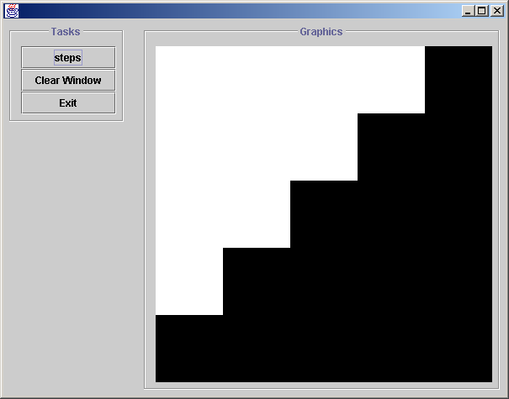

Problem 5: Refining a Class Definition.
Please refer to the attached code for the Class Cube.

(a) Write an instance method with the header

public boolean isHigherThan(Cube otherCube)

that can be invoked on Cube objects and will return true if the top of the Cube object on which this method is invoked is higher (in the graphics window) than the top of otherCube, and return false otherwise.

(b) Look at the instance method adjustToFit. It modifies the x and y coordinates for a given cube so that cube can be displayed entirely within the graphics window. But consider what happens if the size of the cube is so large that it won’t fit entirely within the window no matter where the center is moved. What modification could be made to adjustToFit to fix the size so this can’t happen (without making the cube smaller than it needs to be)? Give a modified definition of adjustToFit that fixes this problem.

Problem 6: Using Objects

(a) Write a code fragment that will define two Cube objects in the specified colors, sizes, and locations, and then display the cubes in the graphics window (named window):

First cube: color: red size: 80.0 center at: (200.0, 200.0)
Second cube: color: blue size: 50.0 center at: (100.0, 300.0)

(b) Write a code fragment that will first define two Cube objects, one red and one green, with random locations and sizes. Then it should print a message: "The red cube is higher." or "The green cube is higher." as appropriate. Use the instance method isHigherThan defined in the previous problem.

(c) Suppose a Cube object c has already been instantiated. Write a code fragment that will simulate lowering this cube by a crane by displaying it first just touching the top of the graphics window, then moving it with animation down one pixel at a time until it just touches the bottom. Assume that a function animate (just as was used in the Animated Loops Lab) is available. The cube’s x and z coordinates and color should remain the same as they were before the animation began.

Problem 7: Class Hierarchy

Suppose we have the following class declarations:

public class A extends B {
...
}

public class B extends C {
...
}

public class C extends D {
...
}

public class D {
...
}

public class E extends C {
...
}

(a) Draw a class hierarchy diagram showing how all these classes are related. Include the class Object in your diagram.

(b) Assume class B has a no-arg constructor. Suppose we use the following code in a program:

B bInstance = new B();
bInstance.doSomething();

If we want to find the source code for the method doSomething, explain which file(s) we might have to look in and why. Is it possible we might find more than one such method definition? If so, how can we tell which one is the one that will be invoked in this case?
Problem 8: Arrays
(a) Suppose an array array1 already exists and is filled with int values. Write a code fragment that declares another array (call it array2) of int values having the same length as array1 and fills it with values so that it looks like a “right-rotated” version of array1. For example, if the contents of array1 looks like this:

3 | 7 | -4 | 10 | 0 | 18

then the contents of array2 should look like this:

18 | 3 | 7 | -4 | 10 | 0

where every element has moved up one index (and the last element has been moved to the first location).

(b) Suppose we are keeping track of United Way charitable contributions by people employed in a small business. There are ten different charities within United Way that we support. We keep the information about the total pledges for each charity in an array of ten integers uw[10] and identify each charity by an integer in the range between 0 and 9.

- Write a complete function newPledge that will ask the user (via the JPT console) to select one of the charities (an int between 0 and 9) then ask for a donation amount (in whole dollars), and will add this amount to the appropriate entry in the uw array. Assume that this array is accessible inside this function (without having to be passed in as an argument). If the user enters an integer outside the range 0-9 for the charity, the function should do something reasonable and not cause the program to crash.
- Write a complete function showPledge that will take as its single argument the id number for one charity and return the total amount pledged for that charity. (No user I/O should be involved.) Assume that the uw array is accessible inside this function (without having to be passed in as an argument).

